**Minimize docker image size for enhanced containerization.  
To optimize the Docker image size, consider utilizing Docker Slim or implementing multi-stage builds. These approaches can significantly reduce the container's footprint, enhancing containerization efficiency  
I have done the task in aws and implemented using multi-stage build  
Go to aws console and create ec2 instance and copy the ssh command**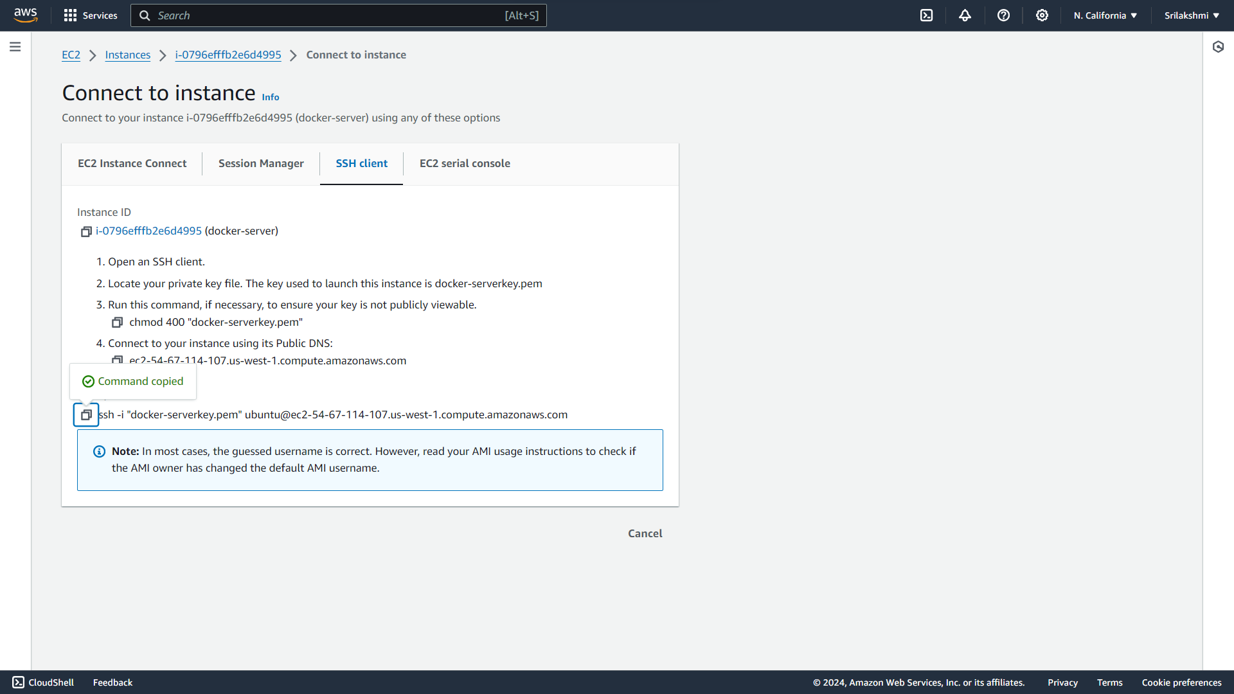

**Connect the ssh command with ubuntu**

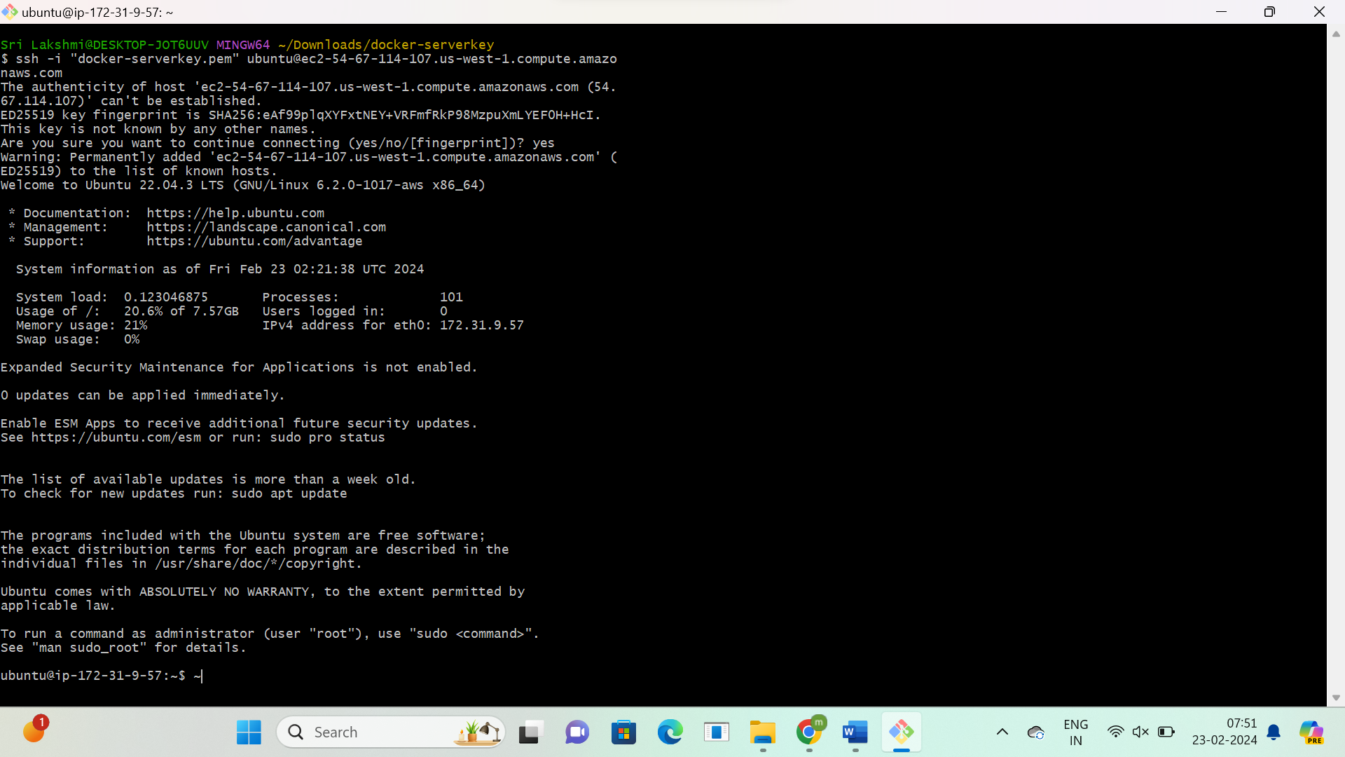

**Install docker**

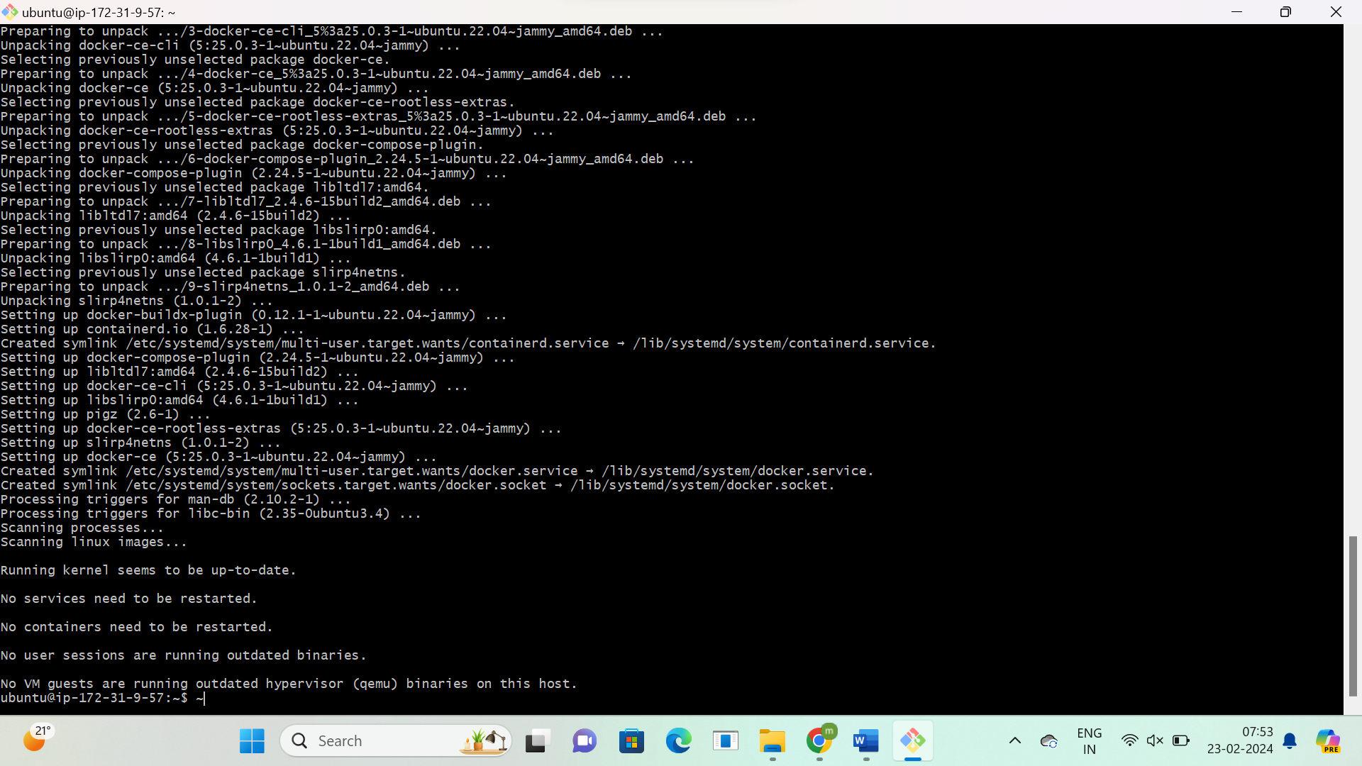

**Switch to root user and create file path**

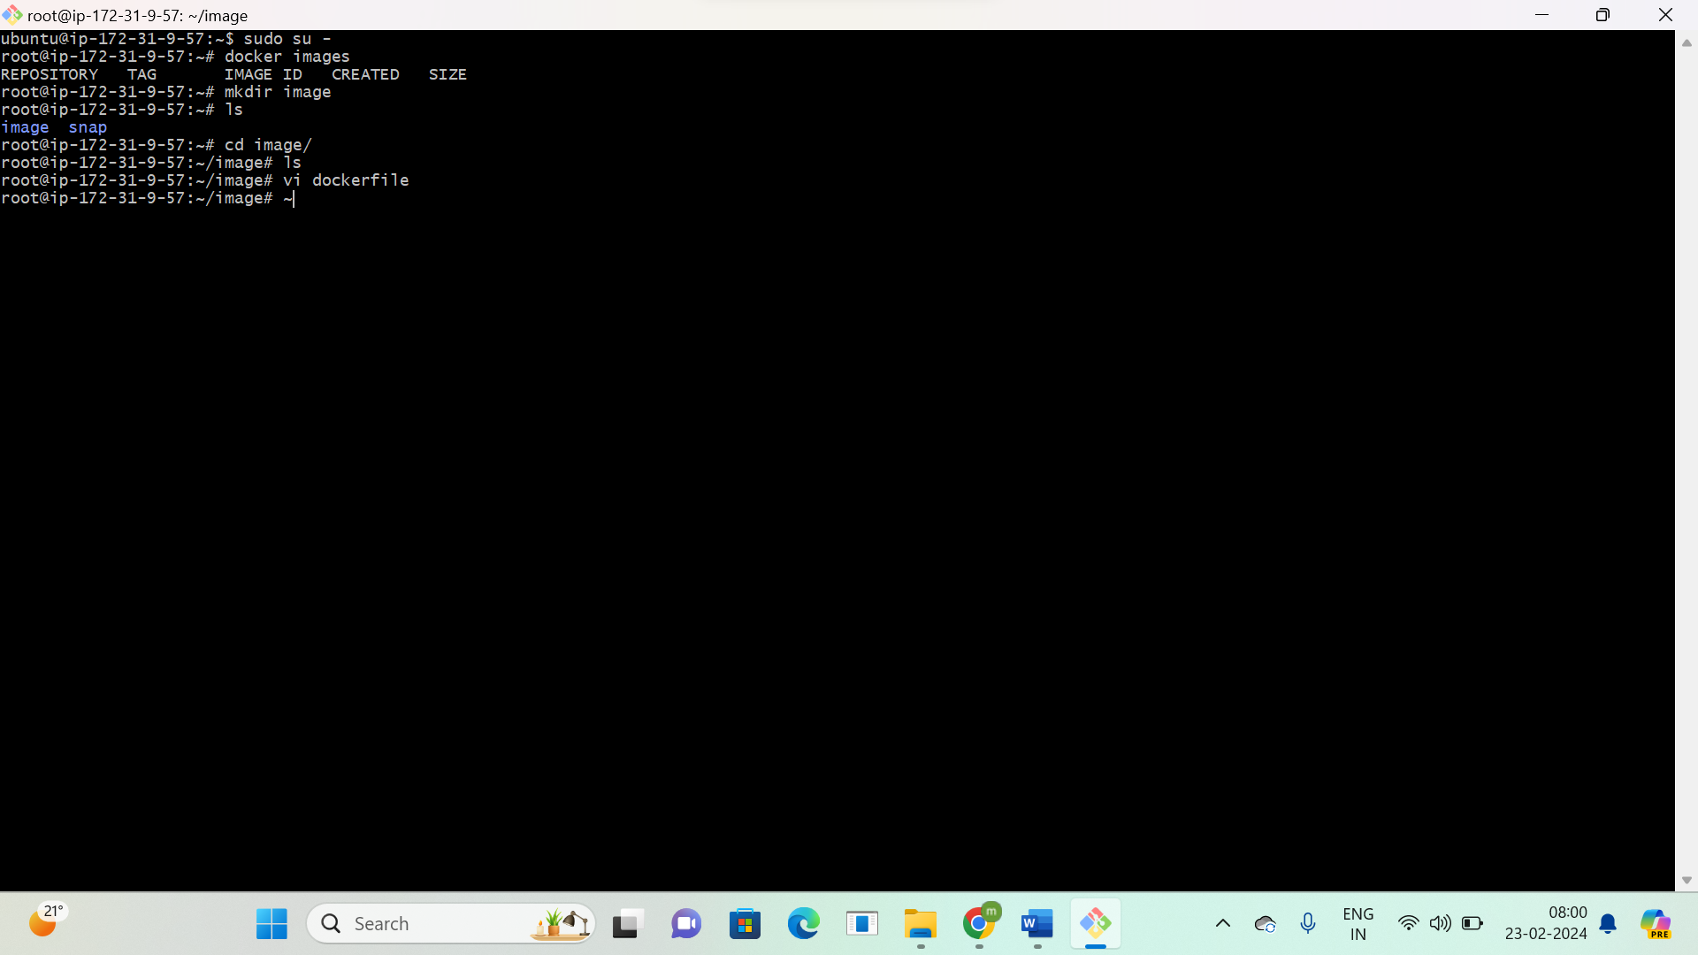

**Give the build stage script**

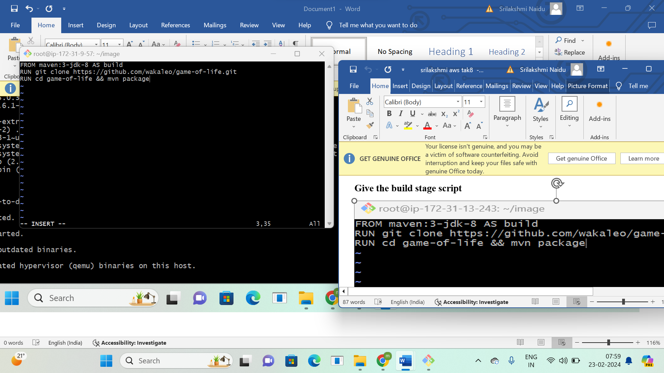

**Created an image size-657MB**

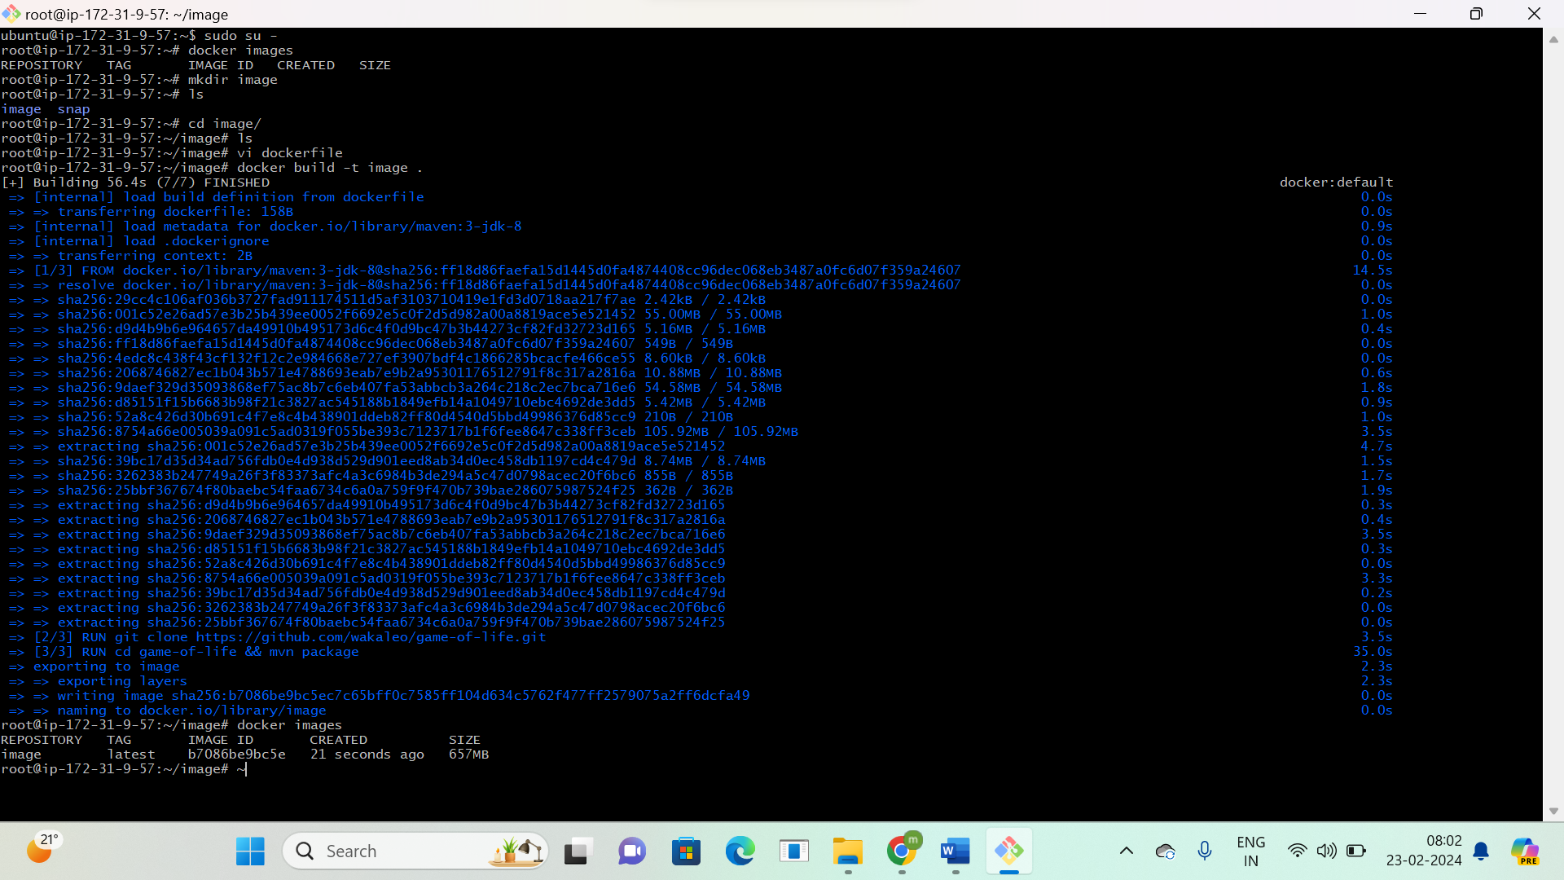

**Go to the same file path and add the deploy stage script**

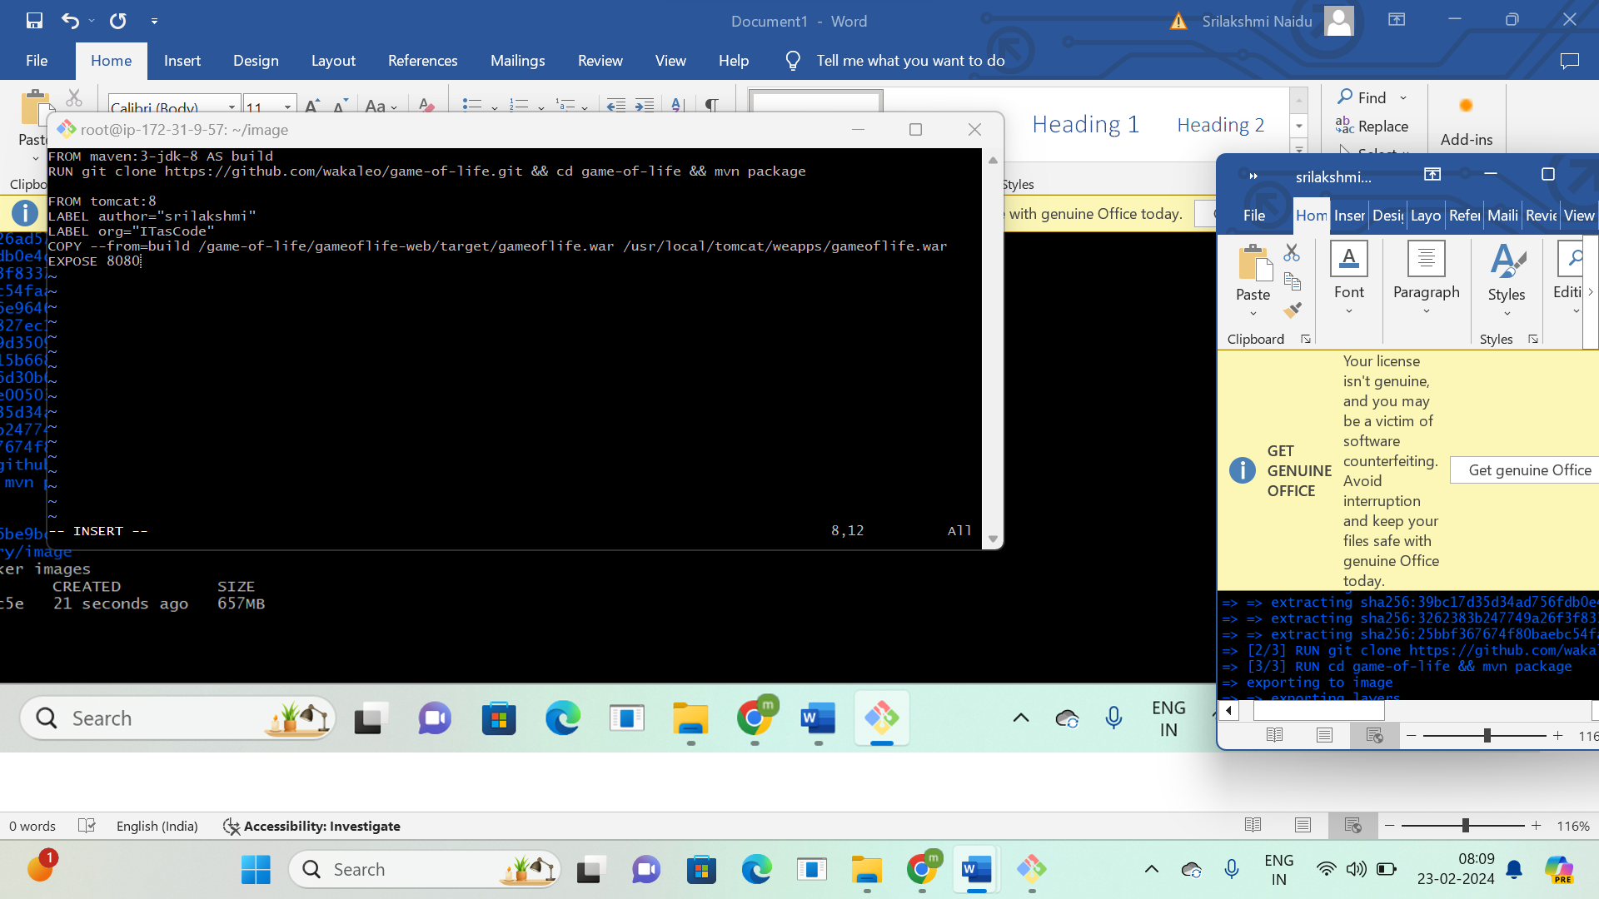

**By using multistage build the image size is reduced from 657MB to 459MB**

